Guidelines for REDX Club logo.

REDX club logo will include three things

* “REDX”,
* Clubs Name
* Clubs location.

For Eg. REDX BKBIET Pilani

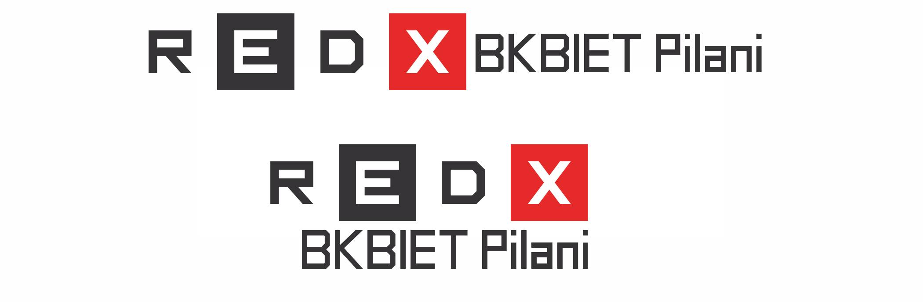

**Font** :

* REDX: **Inversionz font**
* Club Name and location : **Dropy font**

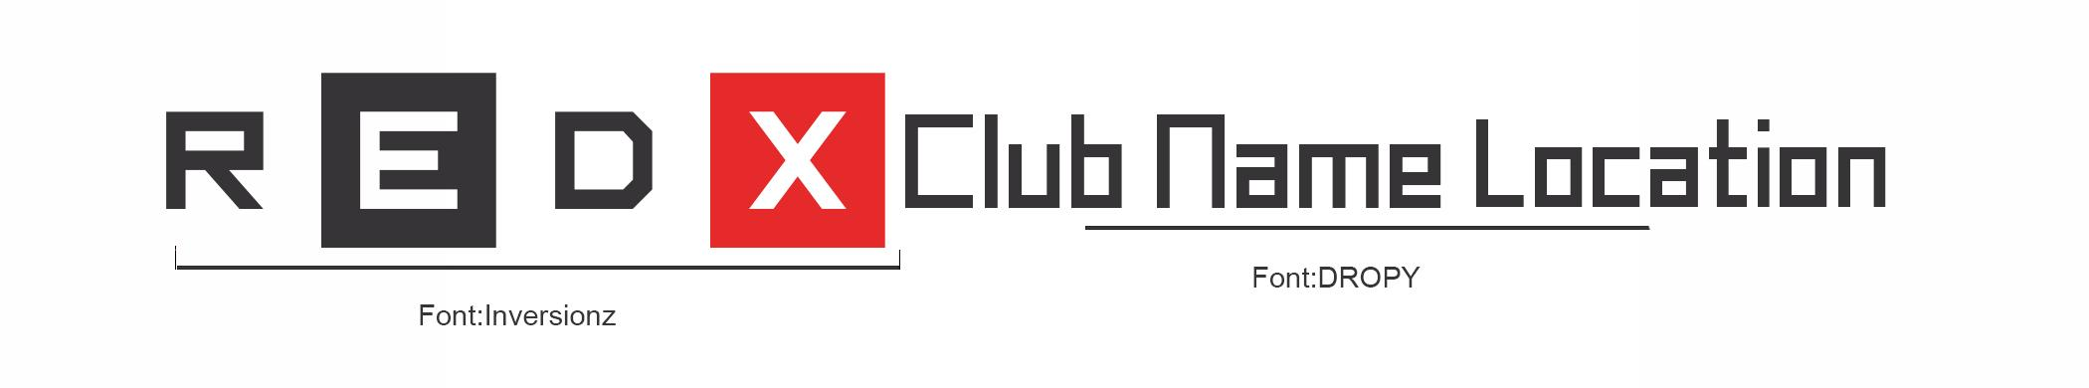

**Font Size for Club Name and Location** :

It should be in alignment with height of letter “R” or “D”

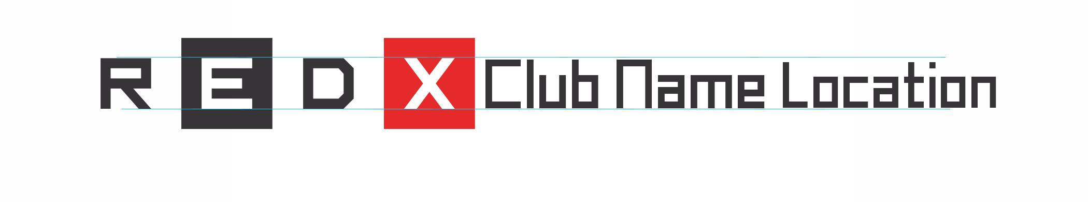

**Colour**

Black: CMYK:69/64/60/56

RGB: 54/52/54

HEX: #363436

RED: CMYK:4/97/95/1

RGB: 229/42/42

HEX: #e52a2a